Policy Setting for Requirement Exclusion

Document version [1.0]

Andrew Simmons

 ®
Note: Before using this information and the product it supports, read the information in "Notices" on page <19>.

© Copyright International Business Machines Corporation <2007> <2013> US Government Users Restricted Rights – Use, duplication or disclosure restricted by GSA ADP Schedule Contract with IBM Corp.

Contents
Contents 3
Revision History 4
1.1 Introduction 5
1.2 Suggested UI Design 6
1.3 Assumptions 6
1.4 Stories 7

Revision History
Date | Version | Revised By | Comments
23 Jul 2014 | 1.0 | AS | First draft

Introduction

It is a requirement to have various policy level settings within the Optimization Workspace which will allow a user with the correct authorization to set certain settings that will govern the behavior of Optimization from a data extraction, display and calculation point of view.

These settings will apply either to all scenarios or to specific scenario types.

This document relates specifically to the setting which enables a user to filter down the set of Requirements that are available to be used for the Optimization calculation and display.

Requirements can already be filtered out at a Scenario level based upon a number of attributes of the corresponding Agreement. Such settings are Required at a policy level – with both sets of parameters being extended to also include a filter related to the underlying Call Amount when the call is not Agreed.

Agreement related
- Business Line
- Principal
- Counterparty - add to Scenario filters
- Agreement

Requirement relates
- Margin Type
- Agreed State
- Call Amount (system) - add to Scenario filters

Example 1: Never optimize Central Clearing lock up requirements
Example 2: Never optimize requirements for Cpty X where the margin call is not yet agreed and the Call Amount is under 500,000 USD (since we know that the cpty never bothers calling under this amount, even though the MTA is 250,000 USD)

Suggested UI Design

A suggested UI for this is as follows:

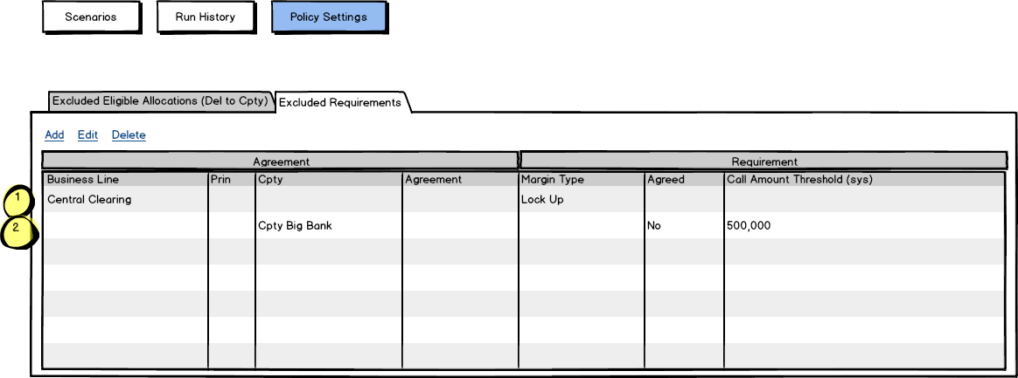

Assumptions

- Settings will be maintained by csv file and UI only
- Settings will apply to ALL Del to Cpty Scenarios only (need to verify)
- Corresponding Requirements will be removed from display

Stories

As a Collateral Manager I require the ability to maintain Policy settings to determine which Requirements are excluded as being available for allocating when any Del to Cpty scenario is run
- New menu option to maintain Policy Eligible Excluded Requirements
- Allow user to maintain a list of exclusion rules, for which to exclude Requirements for all Del to Cpty Scenarios
- A rule can consist of Agreement level filters as follows:
  - Business Line
  - Principal
  - Counterparty
  - Agreement Name
- A rule can also consist of Requirement level filters as follows:
  - Margin Type
  - Agreed Status
  - Call Amount Threshold (sys)
- Multiple rules may be defined, each defining Agreement and/or Requirement level filters
- Selected filters will work in an AND fashion with each other
- A blank will mean no filter on that parameter

As a Collateral Manager I require that when Requirements are extracted and displayed, where they match a Policy Exclusion rule, then they are removed from the list of Requirements accordingly
- When a Del to Cpty Scenario is run exclude the corresponding Requirement when it matches ALL criteria defined in any Policy Setting Rule
- Do not display/use Requirements that are not covered at a Policy level
  - Agreed Status can have value “true” or “false”
  - Call Amount (in System Ccy) will need to be passed into the WS from V5
  - If the Call Amount on a Requirement is less than or equal to the Call Amount Limit specified then exclude that Requirement

Notices

This information was developed for products and services offered worldwide.

Consult your local IBM representative for information on the products and services currently available in your area. Any reference to an IBM product, program, or service is not intended to state or imply that only that IBM product, program, or service may be used. Any functionally equivalent product, program, or service that does not infringe any IBM intellectual property right may be used instead. However, it is the user's responsibility to evaluate and verify the operation of any non-IBM product, program, or service.

IBM may have patents or pending patent applications covering subject matter described in this document. The furnishing of this document does not grant you any license to these patents. You can send license inquiries, in writing, to:

IBM Director of Licensing
IBM Corporation
North Castle Drive
Armonk, NY 10504-1785
U.S.A.

The following paragraph does not apply to the United Kingdom or any other country where such provisions are inconsistent with local law:

INTERNATIONAL BUSINESS MACHINES CORPORATION PROVIDES THIS PUBLICATION "AS IS" WITHOUT WARRANTY OF ANY KIND, EITHER EXPRESS OR IMPLIED, INCLUDING, BUT NOT LIMITED TO, THE IMPLIED WARRANTIES OF NON-INFRINGEMENT, MERCHANTABILITY OR FITNESS FOR A PARTICULAR PURPOSE. Some states do not allow disclaimer of express or implied warranties in certain transactions, therefore, this statement may not apply to you.

This information could include technical inaccuracies or typographical errors. Changes are periodically made to the information herein; these changes will be incorporated in new editions of the publication. IBM may make improvements and/or changes in the product(s) and/or the program(s) described in this publication at any time without notice.

Any references in this information to non-IBM Web sites are provided for convenience only and do not in any manner serve as an endorsement of those Web sites. The materials at those Web sites are not part of the materials for this IBM product and use of those Web sites is at your own risk.

IBM may use or distribute any of the information you supply in any way it believes appropriate without incurring any obligation to you.

Information concerning non-IBM products was obtained from the suppliers of those products, their published announcements or other publicly available sources. IBM has not tested those products and cannot confirm the accuracy of performance, compatibility or any other claims related to non-IBM products. Questions on the capabilities of non-IBM products should be addressed to the suppliers of those products.

All statements regarding IBM's future direction or intent are subject to change or withdrawal without notice, and represent goals and objectives only.

If you are viewing this information softcopy, the photographs and color illustrations may not appear.
Trademarks
IBM, the IBM logo, and ibm.com are trademarks or registered trademarks of International Business Machines Corporation in the United States, other countries, or both. If these and other IBM trademarked terms are marked on their first occurrence in this information with a trademark symbol (® or ™), these symbols indicate U.S. registered or common law trademarks owned by IBM at the time this information was published. Such trademarks may also be registered or common law trademarks in other countries. A current list of IBM trademarks is available on the web at "Copyright and trademark information" at http://www.ibm.com/legal/copytrade.shtml.
        - Include the following company attribution statements only if you mention any of them in your paper. Remove the ones that don’t apply.
        - The latest list of non-IBM trademarks that you must attribute are listed here: http://www.ibm.com/legal/us/en/copytrade.shtml#section_4
Adobe, the Adobe logo, PostScript, and the PostScript logo are either registered trademarks or trademarks of Adobe Systems Incorporated in the United States, and/or other countries.

IT Infrastructure Library is a registered trademark of the Central Computer and Telecommunications Agency which is now part of the Office of Government Commerce.

Intel, Intel logo, Intel Inside, Intel Inside logo, Intel Centrino, Intel Centrino logo, Celeron, Intel Xeon, Intel SpeedStep, Itanium, and Pentium are trademarks or registered trademarks of Intel Corporation or its subsidiaries in the United States and other countries.

Linux is a registered trademark of Linus Torvalds in the United States, other countries, or both.

Microsoft, Windows, Windows NT, and the Windows logo are trademarks of Microsoft Corporation in the United States, other countries, or both.

ITIL is a registered trademark, and a registered community trademark of The Minister for the Cabinet Office, and is registered in the U.S. Patent and Trademark Office.

UNIX is a registered trademark of The Open Group in the United States and other countries.

Java and all Java-based trademarks and logos are trademarks or registered trademarks of Oracle and/or its affiliates.

Cell Broadband Engine is a trademark of Sony Computer Entertainment, Inc. in the United States, other countries, or both and is used under license therefrom.

Linear Tape-Open, LTO, the LTO Logo, Ultrium, and the Ultrium logo are trademarks of HP, IBM Corp. and Quantum in the U.S. and other countries.

®

